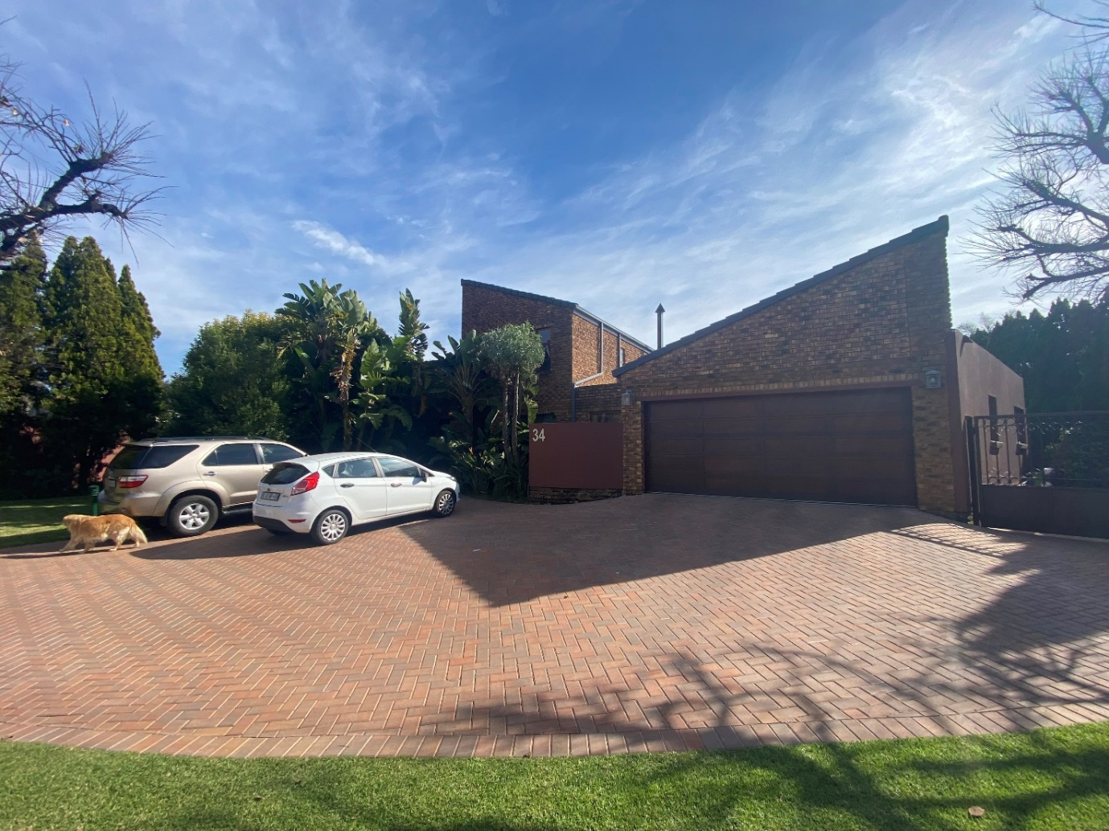

Valuation Report

34 Aintree crescent

Stuart Kieser

DATE: 2023/06/03

Contents

1. Introduction 2

1.1 Instruction 2

1.2 Relevant inspection dates of report 2

1.3 Consideration of properties to be valued 2

1.4 Market Value 2

2. Definitions 3

2.1 Definition of open market value 3

2.2 Market value Establishment 3

3. Title deed information 3

4. Local Authority Information 3

4.1 Local Authority 3

4.2 Zoning 3

4.3 Assessment Rates 4

5. Property Details 4

5.1 Physical address 4

5.2 Location & surrounding area 4

5.3 Physical description 5

5.4 Improvements 6

5.5 Accommodation offered. 6

# Introduction

## Instruction

As per request, the valuation of a property is to be valued to the standards set out by the South African Council for the property Valuers Profession. The highest and best use case is calculated in the following report.

## Relevant inspection dates of report

Date of inspection: 2023/07/14

Date of compilation of report: 2023/08/to be entered

Effective date of valuation: To be entered

## Consideration of properties to be valued

The valuation of a building is broken down into a scope of work for the property. The valuer has to determine what the valuation scope is, and the method that will be used for valuation. For this report, a sales comparison approach is used to determine the properties value.

The sales approach entails comparing the sales data and other relevant data of surrounding markets and properties down to a micro level of investigation. Where the house undergoes further inspection with reference to building plans acquired from the SG (surveyor general).

Only after thorough investigation can the highest and best used of a property be determined according to the work set out by Douw Boshoff.

## Market Value

R3 000 000 THREE MILLION RAND

# Definitions

## Definition of open market value

Open market value is described as the value of a property in a market where both a willing buyer and willing seller are knowledgeable of the worth of the property acting without compulsion or spontaneity.

## Market value Establishment

Through the use of the definition above, the market value of a property will be determined within a value range.

Similar sales data and property transactions will be used as reference data best suited to the attributes of the property.

# Title deed information

|  |  |
| --- | --- |
| Township: | Kyalami |
| Title Deed Number: | - |
| Erf: | 25 |
| Portion: | 1 |
| Extent: | 1256 SQM |
| Registered owner: | Glenn Kieser |
| Previous purchase price | R720000 |
| Purchase date | 2000-08-13 |
| Bond | Access Bond |

*The above Title Deed Information is applicable to the reigning Title Deed, some of which would change on transfer, registration or in case of any additional endorsements being registered.*

# Local Authority Information

## Local Authority

The subject property is situated within the boundaries of the Johannesburg Metropolitan Municipality. Within Kyalami Estates, a gated community.

## Zoning

|  |  |
| --- | --- |
| Zoning | Residential |
| Coverage | 50% |
| FAR | 0.8 |
| Height restrictions | Must not exceed a height of 9m for a double storey |
| Building lines | Frontage: 5 metres  Sides: Aggregate 6 metres with a minimum of 2.25 metres on one side Rear: 2.25 metres |

*Physical inspection revealed that the utilisation of improvements at present has not been in contravention of the local bylaws/zoning.*

## Assessment Rates

TBD

# Property Details

## Physical address

34 Aintree Crescent, Kyalami Estates, Midrand.

## Location & surrounding area

**Micro Locality**

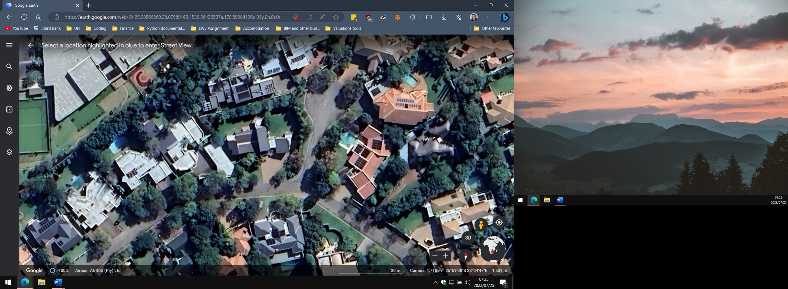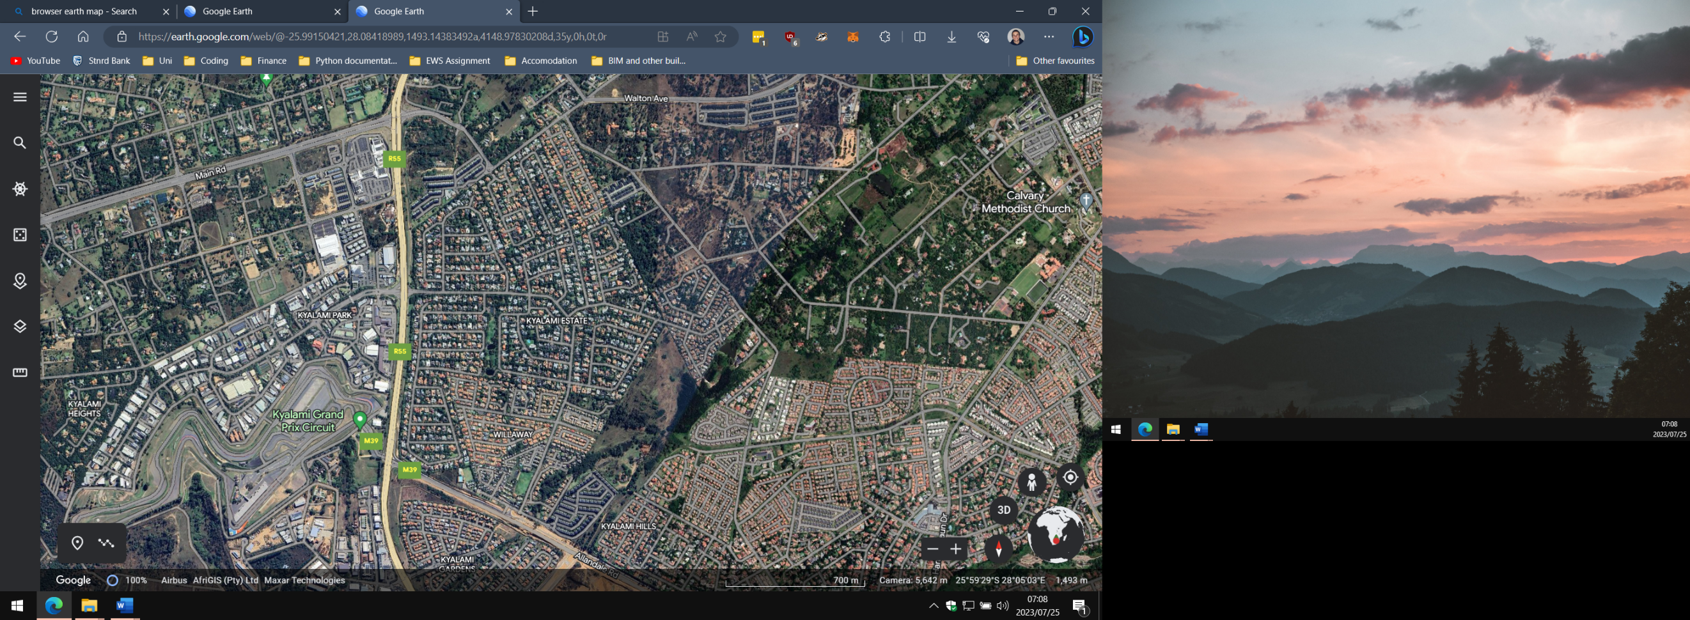

The subject property is located within an enclosed estate: Kyalami Estates. The Property is located near the top entrance of the estate accessible via the R55 past the Kyalami racetrack. Located south of Sandton and east of Fourways. The estate enjoys a centrality to most required services and leisure activities. The estate is primarily compromised of residential dwellings stretching two stories aimed at high middle to high income families.

**Macro locality**

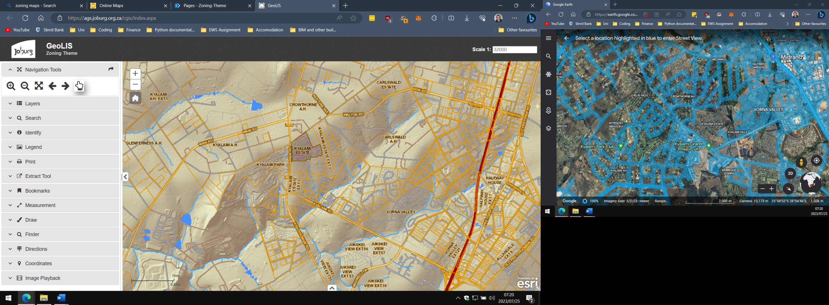

Kyalami is located south of Beaulieu estates, Crowthrone, far north of Sandton City CBD and 4 to 5 kms from the nearest major arterial roadway (N1). The suburb enjoys a decent centrality to most major amenities. With multiple fuel ports, shopping centres, schools and strip located in the immediate surround areas.

## Physical description

* + 1. The Site

Shape: The subject property has a trapezoid like shape, with the longest edge facing north

Site Boundaries: The south boundary faces Aintree Crescent Street. The eastern boundary borders on Epsom close. The other two boundaries border on other erven.

Topography: The site is considerable level and no major elevation changes are present.

Soil Conditions: The soil is stable, there is no sign of bulging ground, or building features. A geotechnical test has not been conducted.

* + 1. Services

All municipal service are supplied to the surrounding areas, such has water, electricity, sewerage and waste removal. The estate is located directly across from a BP Fuel Port.

* + 1. Property Characteristics

Visibility: South and East facing facades of the building are visible to on lookers, North and west façades face other properties and are obscured by the boundary wall.

Accessibility: The property is highly accessible from main motorways such as the N1 highway and R55 and Is located across the Road from Kyalami Racetrack. Entering through Kyalami’s top gate located near the racetrack, tack you first left inside the estate and follow the road up Aintree Crescent until the cul’de sac. The property is located on your left. Alternatively, entering the estate from the bottom gate located up the road from Kyalami Preparatory school. Follow the main road until the very last right and follow the road all the way up Aintree Crescent.

External: The subject dwelling is a blend of industrial and modern architectural styles. The exterior facades boast a red face brick styling with partial walls being painted with a reddish/maroon colour

Materials: The structure of the house is built on brick and mortar; the ceiling tiles are black concrete/cement.

Finishes: The subject property is finished with a faced brick Flemish bond, Red paint covers the boundary walls.

Internal: Internally the property is built around a single main passageway connecting the bedrooms to the kitchen, dining room, lounge and main communal area.

Materials: The interior consists mainly of brick structure, each room is fully carpeted, the wooden ceiling beams are visible to the eye and covered with white paint.

Finishes: The interior of the house s finished between red and white paint. The floors are tiled with a burgundy tile.

# 5.4 Improvements

The property does not appear to have any visible enhancements as of the last 10 years, the main structure is very much similar to the SG diagrams.

# 5.5 Accommodation offered.

**Gross Building Area**

Main Building: 216.93 SQM.

Outbuildings: -

Covered areas: 15.63 SQM.

Pergola terrace: -

**Total: 232.56 SQM.**

The subject property has three bedrooms, 1 master bedrooms and 2 smaller bedrooms, the two bedrooms shares a bathroom while the master bedroom has its own facilities. The subject property has 2.5 bathrooms and one shower, both bathrooms have baths. There is an upstairs office space and spare storage locker near the garage.